**CS385 Homework 5**

**7.20**

a. List the entity sets and their primary keys.

* Author (name, address, URL)
* Primary key: name
* Publisher (name, address, phone, URL)
* Primary key: name
* Book (ISBN, title, year, price)
* Primary key: ISBN
* Customer (email, name, address, phone)
* Primary key: email
* Warehouse (code, address, phone)
* Primary key: code

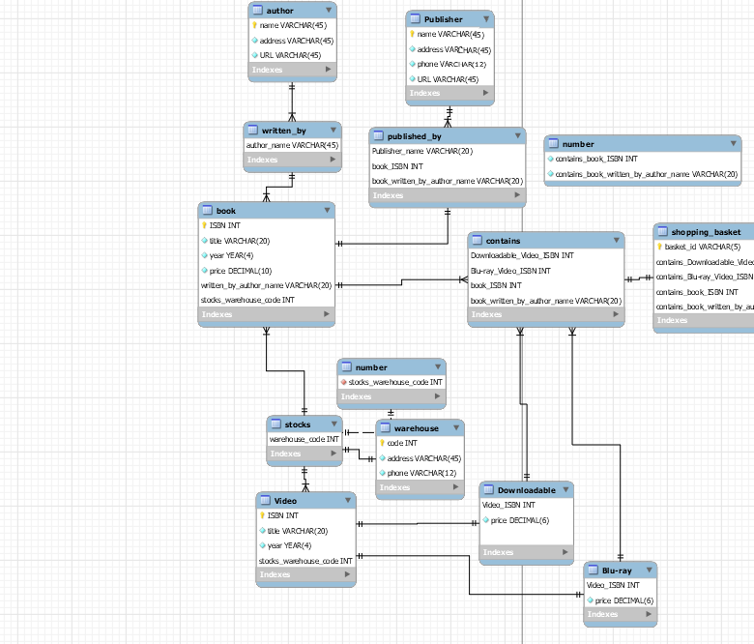b. Suppose the bookstore adds Blu-ray discs and downloadable video to its collection. The same item may be present in one or both formats, with differing prices. Extend the E-R diagram to model this addition, ignoring the effect on shopping baskets.

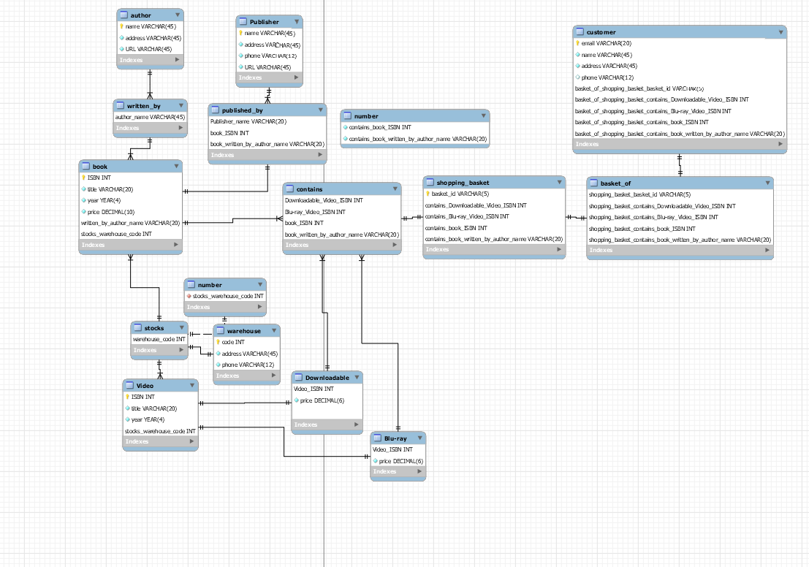c. Now extend the E-R diagram, using generalization, to model the case where a shopping basket may contain any combination of books, blue-ray discs, or downloadable video.